Obvious Office Narrative Design

# Story Overview

You play as the famous gravity hero Newtonius, who has a secret identity that protects his family from his many enemies. Whilst you’re working a usual day in the office, your arch nemesis Inveig attacks in hopes of uncovering your secret.

As you help the people of the office on your way through, some start to suspect that you are the hero. Others start losing faith in the hero because he’s not saving everyone. With the help of your sidekick, you head to a top floor to equip your hero suit that has been deployed. Unfortunately, when you get there an explosion destroys the hero pod and severs the hero’s communication with his sidekick.

At this point a choice can be made about whether to head to the rooftop to reveal your true identity, or to head to the bottom floor, saving as many people as you can and escaping with the rest of the office denizens. Revealing yourself allows you to save everyone, and garners the admiration of the public, but endangers your family and possibly forces you to cut contact with them. Escaping with the rest of the workers doesn’t put your family in danger, but causes the public to lose their faith in Newtonius.

In the end it’s a story of the hero making tough decisions and the villain winning the day.

# Vertical Slice

On a normal day in the life of your secret identity, you’re going through the usual motions. Whilst you’re getting your work done a massive commotion happens, causing everyone in the office to panic. Your arch nemesis has found your location, and there are mines placed all throughout the building. The villain explains that he’s taking the building hostage until the hero reveals his secret identity to the world, which would put your family in danger.

Being a famous hero, you believe that everyone can be saved without using your powers. Enlisting the help of your sidekick and his gadgets, you help the office people and take care of the mines that block the way. These actions however cast some suspicion on you, as the average worker wouldn’t risk his neck like that. There are also people who are extremely displeased that the hero isn’t saving everyone, as they are unaware of the troubling circumstances you find yourself in.

The villain throws another spanner in the works by offering safety to any worker that betrays the hero’s real identity. You now have to be careful about the extra eyes on you, as you try to save the people that are slowing turning against you.

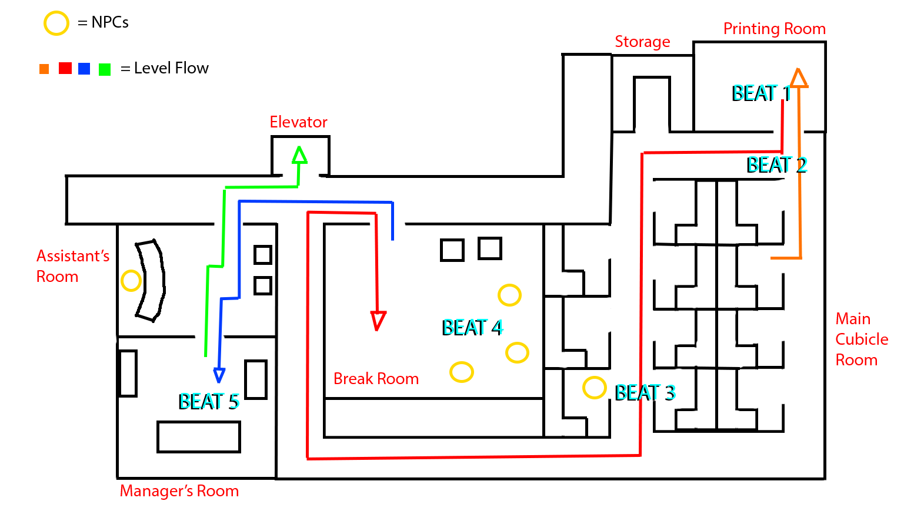

# Character Profiles

## Hero – Newtonius

Age: 36

Build: Athletic

A famous hero who uses gravity powers. Has a secret identity to protect his wife and kids from publicity and the villains he faces.

Newtonius is a traditional hero who always sees the positive in the situation. His strong sense of justice makes the office scenario an extremely tough decision as he doesn’t want to put his innocent family in danger, but also doesn’t feel right selfishly abandoning his co-workers.

* Is a mentor to his sidekick Isaac.
* Has been trying to take down Inveig for many years but can never manage to capture him for long.

## Villain – Inveig

Age: 40

Build: Slim

Newtonius’ arch nemesis, always trying to place him in situations with difficult decisions. He knows that the true way to break a hero is to destroy their spirit; create something they cannot overcome.

He never puts himself in danger and usually sends his mechanical creations to wreak havoc. He has always loved watching people struggle with dilemmas that strike at a person’s core.

* He speaks and acts in a posh way to convey his intellectual superiority.
* Is very smart but is often undone by not grasping the true depth of a person’s character until too late.
* Each subsequent defeat seems to be leading him further into insanity.

## Sidekick – Isaac

Age: 20

Build: Slim/Athletic

A young man who was saved by Newtonius when he was a boy. He tracked the hero down with his incredible gadgets, impressing Newtonius enough to consider training him.

Inspired by his saviour’s actions, Isaac hopes to one day be an equally mighty hero.

* Has a brilliant tactical mind that allows him to be a very effective support or “guy in the chair”.
* Is constantly trying to ground Newtonius and make him take situations more seriously.
* He evaluates the pros and cons of every situation and performs hero work more analytically.

# Narrative Planning

The overall gameplay was created first, so it was mainly the story that was made to fit the gameplay.

* The player’s character having gravity powers fits into both the story and gameplay:
  + Is a power that can’t be used discretely in the open (thus limiting mechanics and creating challenge for hero)
  + Powers similar to current mechanics (would actually work if implemented in later levels)
  + Allows the sidekick to enter the story smoothly (detects the mines for the hero/making up for what he lacks)
* I wanted a flashy animation to end the level, which is the elevator door opening. Taking the elevator during an emergency is quite unusual, so it had to be explained in the story that the stairwell was damaged in an explosion.
* The character having powers that they can’t use served the narrative well, by creating suspense and drama around whether or not the people of the office would find out the hero’s identity